**Лабораторная работа №4.**    
«Сложные SQL запросы»

**Задание 1 (NF)**

1. Привести нермализованную таблицу из задания к 1NF и создать таблицу с данными для ее
2. Привести 1NF к 2NF, а 2NF к 3NF

**Задание 2 (views)**

1. На основании 1NF создать представления представляющие собой 2NF

CREATE

ALGORITHM = UNDEFINED

DEFINER = `root`@`localhost`

SQL SECURITY DEFINER

VIEW `2nf_teams and drivers 2017` AS

SELECT

`teams and drivers 2017`.`ChampionShip_year` AS `ChampionShip_year`,

`teams and drivers 2017`.`Entrant` AS `Entrant`,

`teams and drivers 2017`.`Entrant_country` AS `Entrant_country`,

`teams and drivers 2017`.`Constructor` AS `Constructor`,

`teams and drivers 2017`.`Chassis` AS `Chassis`,

`teams and drivers 2017`.`Power unit` AS `Power unit`,

`teams and drivers 2017`.`Tyres` AS `Tyres`,

`teams and drivers 2017`.`№` AS `№`,

`teams and drivers 2017`.`id` AS `id`

FROM

`teams and drivers 2017`

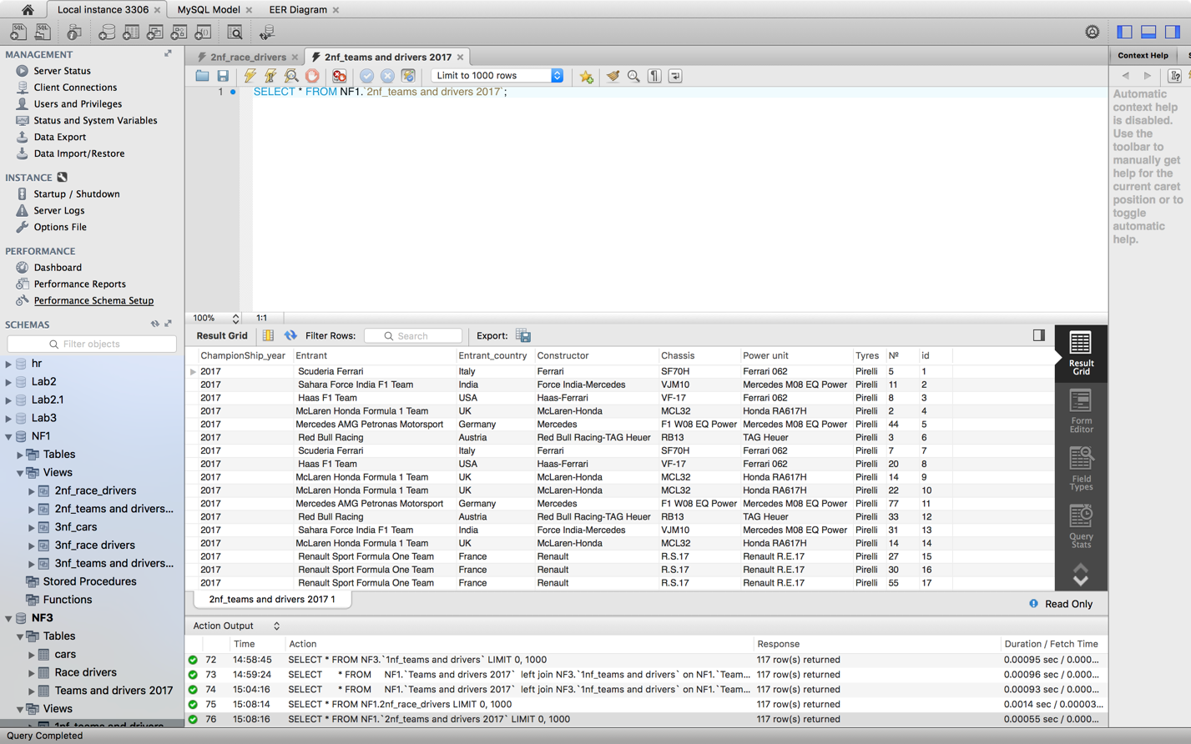

CREATE

ALGORITHM = UNDEFINED

DEFINER = `root`@`localhost`

SQL SECURITY DEFINER

VIEW `2nf_race_drivers` AS

SELECT

`teams and drivers 2017`.`№` AS `№`,

`teams and drivers 2017`.`Driver Country` AS `Driver country`,

`teams and drivers 2017`.`Driver name` AS `Driver name`,

`teams and drivers 2017`.`Driver surname` AS `Driver surname`,

`teams and drivers 2017`.`Rounds` AS `Rounds`

FROM

`teams and drivers 2017`

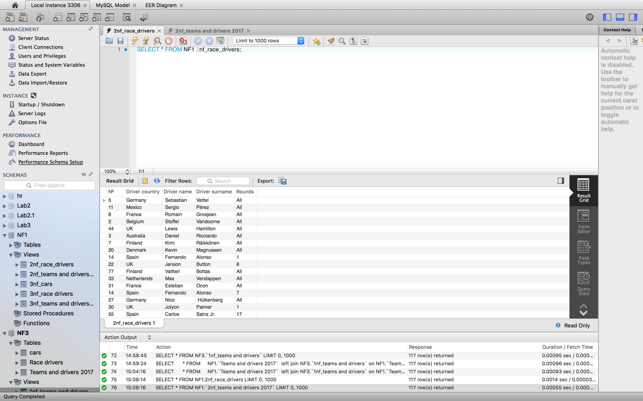

1. На основании представлений 2NF создать представления представляющие собой 3NF

CREATE

ALGORITHM = UNDEFINED

DEFINER = `root`@`localhost`

SQL SECURITY DEFINER

VIEW `3nf_cars` AS

SELECT

`2nf_teams and drivers 2017`.`Entrant` AS `Entrant`,

`2nf_teams and drivers 2017`.`Entrant_country` AS `Entrant_country`,

`2nf_teams and drivers 2017`.`Constructor` AS `Constructor`,

`2nf_teams and drivers 2017`.`Chassis` AS `Chassis`,

`2nf_teams and drivers 2017`.`Power unit` AS `Power unit`,

`2nf_teams and drivers 2017`.`Tyres` AS `Tyres`

FROM

`2nf_teams and drivers 2017`

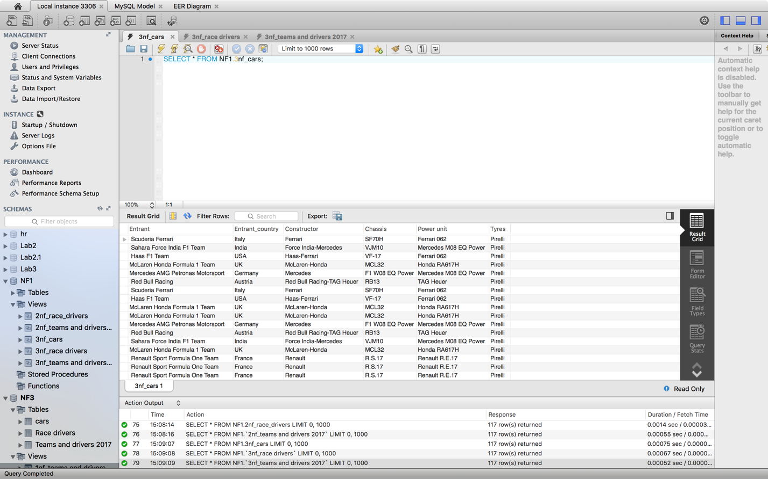

CREATE

ALGORITHM = UNDEFINED

DEFINER = `root`@`localhost`

SQL SECURITY DEFINER

VIEW `3nf_race drivers` AS

SELECT

`2nf_race_drivers`.`№` AS `№`,

`2nf_race_drivers`.`Driver country` AS `Driver country`,

`2nf_race_drivers`.`Driver name` AS `Driver name`,

`2nf_race_drivers`.`Driver surname` AS `Driver surname`,

`2nf_race_drivers`.`Rounds` AS `Rounds`

FROM

`2nf_race_drivers`

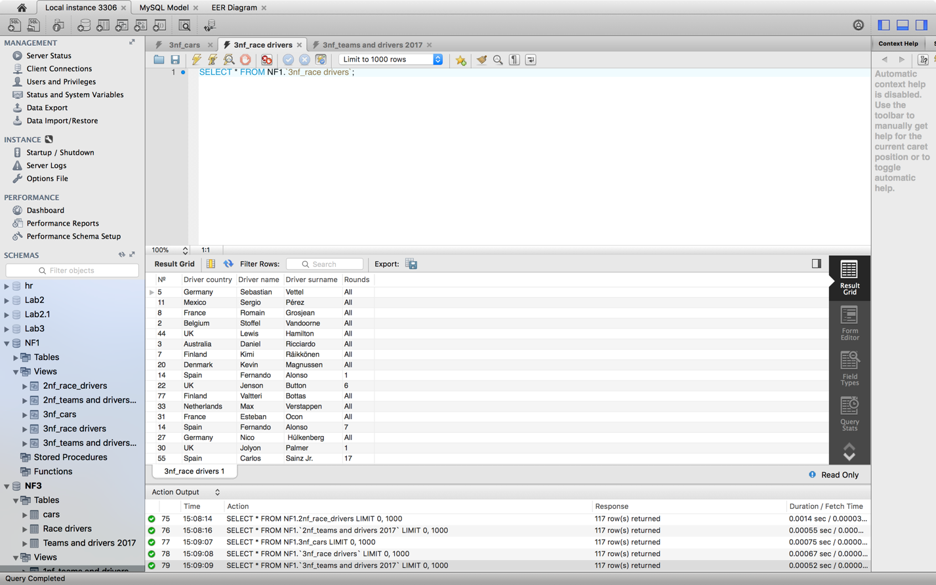

CREATE

ALGORITHM = UNDEFINED

DEFINER = `root`@`localhost`

SQL SECURITY DEFINER

VIEW `3nf_teams and drivers 2017` AS

SELECT

`2nf_teams and drivers 2017`.`ChampionShip_year` AS `ChampionShip_year`,

`2nf_teams and drivers 2017`.`Entrant` AS `Entrant`,

`2nf_teams and drivers 2017`.`№` AS `№`,

`2nf_teams and drivers 2017`.`id` AS `id`

FROM

`2nf_teams and drivers 2017`

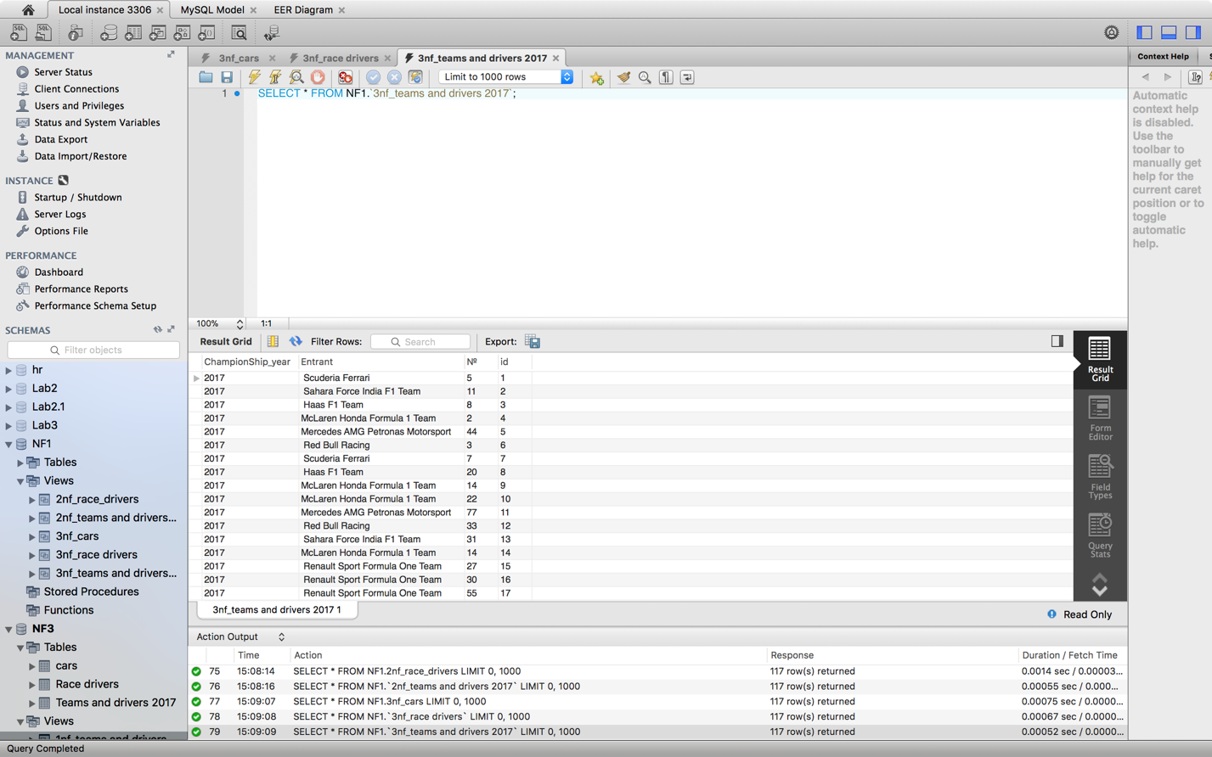

**Задание 3 (подзапросы, добавление данных)**

1. На основании представлений из 3NF создать таблицы и вставить данные в таблицы для 3NF с необходимыми FK для этой нормальной формы.

-- MySQL Script generated by MySQL Workbench

-- Sat Mar 24 15:18:39 2018

-- Model: New Model Version: 1.0

-- MySQL Workbench Forward Engineering

SET @OLD_UNIQUE_CHECKS=@@UNIQUE_CHECKS, UNIQUE_CHECKS=0;

SET @OLD_FOREIGN_KEY_CHECKS=@@FOREIGN_KEY_CHECKS, FOREIGN_KEY_CHECKS=0;

SET @OLD_SQL_MODE=@@SQL_MODE, SQL_MODE='TRADITIONAL,ALLOW_INVALID_DATES';

-- -----------------------------------------------------

-- Schema NF3

-- -----------------------------------------------------

-- -----------------------------------------------------

-- Schema NF3

-- -----------------------------------------------------

CREATE SCHEMA IF NOT EXISTS `NF3` ;

USE `NF3` ;

-- -----------------------------------------------------

-- Table `NF3`.`cars`

-- -----------------------------------------------------

CREATE TABLE IF NOT EXISTS `NF3`.`cars` (

`Entrant_country` TEXT(100) NOT NULL,

`Entrant` TEXT(100) NOT NULL,

`Constructor` TEXT(100) NOT NULL,

`Chassis` TEXT(100) NOT NULL,

`Power unit` TEXT(100) NOT NULL,

`Tyres` VARCHAR(45) NOT NULL,

`Entrant id` INT NOT NULL,

PRIMARY KEY (`Entrant id`))

ENGINE = InnoDB;

-- -----------------------------------------------------

-- Table `NF3`.`Teams and drivers 2017`

-- -----------------------------------------------------

CREATE TABLE IF NOT EXISTS `NF3`.`Teams and drivers 2017` (

`ChampionShip_year` INT NOT NULL,

`Entrant id` INT NOT NULL,

`Drivers id` INT NOT NULL,

INDEX `fk_Teams and drivers 2017_cars1_idx` (`Entrant id` ASC),

PRIMARY KEY (`Drivers id`),

CONSTRAINT `fk_Teams and drivers 2017_cars1`

FOREIGN KEY (`Entrant id`)

REFERENCES `NF3`.`cars` (`Entrant id`)

ON DELETE NO ACTION

ON UPDATE NO ACTION)

ENGINE = InnoDB;

-- -----------------------------------------------------

-- Table `NF3`.`Race drivers`

-- -----------------------------------------------------

CREATE TABLE IF NOT EXISTS `NF3`.`Race drivers` (

`id` INT NOT NULL,

`№` INT NOT NULL,

`Driver Country` TEXT(100) NOT NULL,

`Driver name` TEXT(100) NOT NULL,

`Driver surname` TEXT(100) NOT NULL,

`Round` VARCHAR(50) NOT NULL,

`Drivers id` INT NOT NULL,

PRIMARY KEY (`id`),

INDEX `fk_Race drivers_Teams and drivers 20171_idx` (`Drivers id` ASC),

CONSTRAINT `fk_Race drivers_Teams and drivers 20171`

FOREIGN KEY (`Drivers id`)

REFERENCES `NF3`.`Teams and drivers 2017` (`Drivers id`)

ON DELETE NO ACTION

ON UPDATE NO ACTION)

ENGINE = InnoDB;

SET SQL_MODE=@OLD_SQL_MODE;

SET FOREIGN_KEY_CHECKS=@OLD_FOREIGN_KEY_CHECKS;

SET UNIQUE_CHECKS=@OLD_UNIQUE_CHECKS;

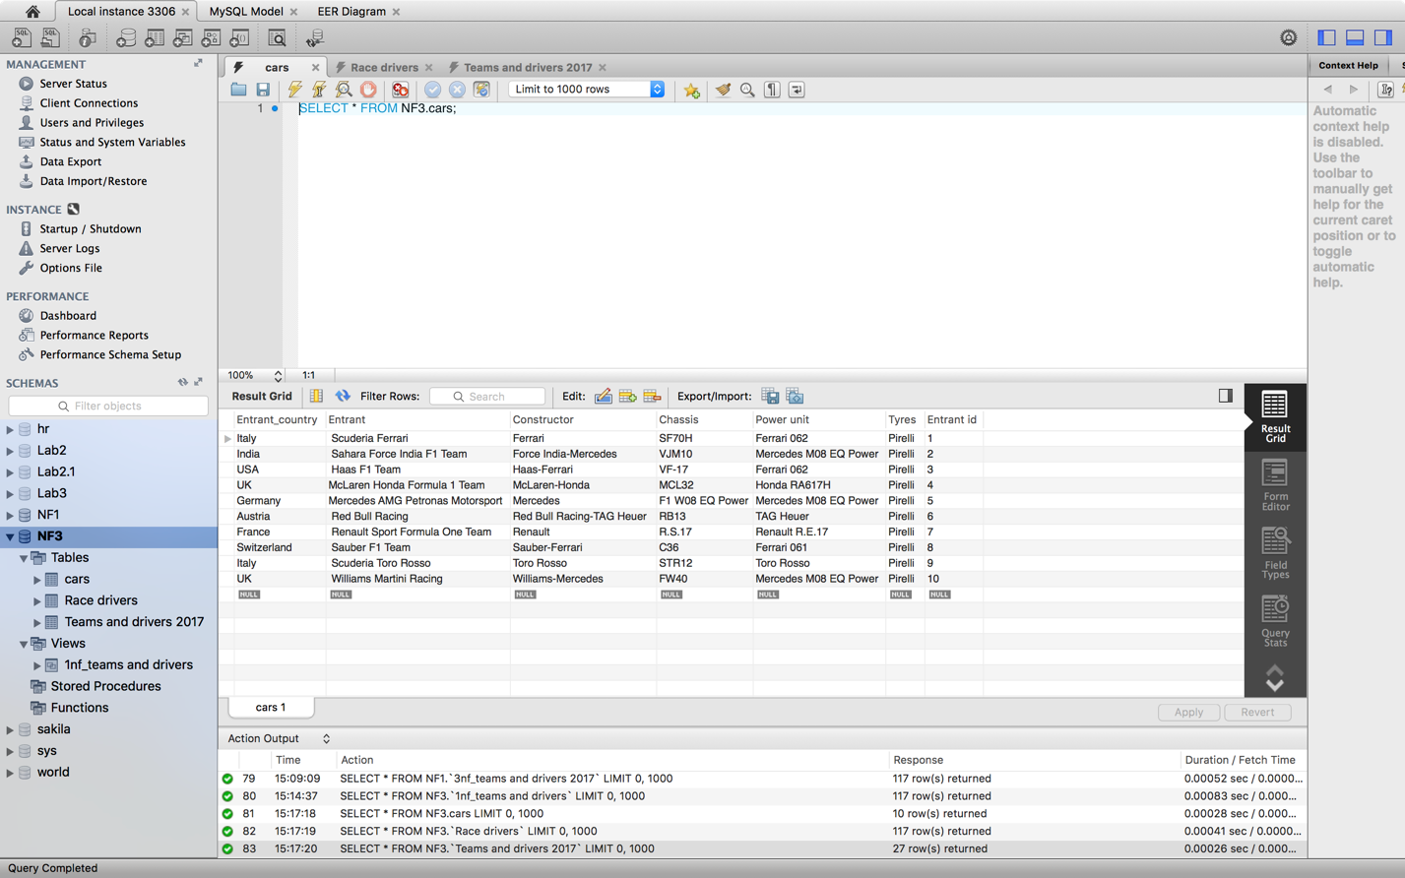

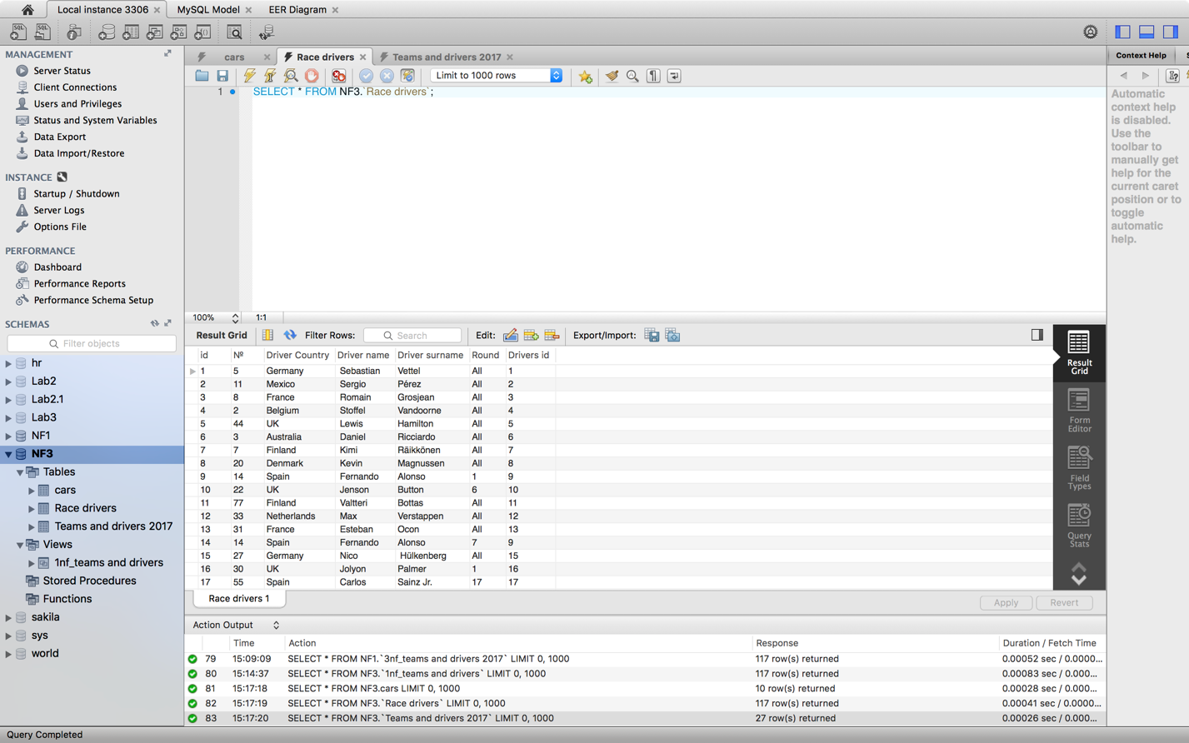

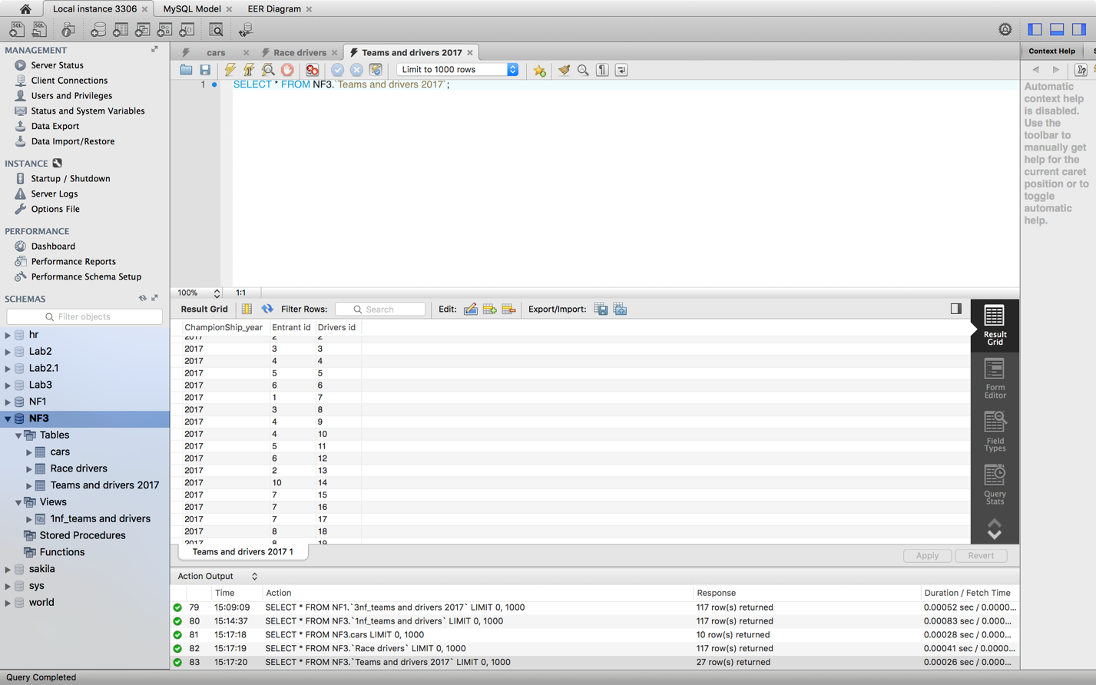

1. Создать представление выводящее базу данныз в 1NF на основании данных из таблиц для 3NF.

CREATE

ALGORITHM = UNDEFINED

DEFINER = `root`@`localhost`

SQL SECURITY DEFINER

VIEW `1nf_teams and drivers` AS

SELECT

`rd`.`id` AS `id`,

`td`.`ChampionShip_year` AS `ChampionShip_year`,

`c`.`Entrant_country` AS `Entrant_country`,

`c`.`Entrant` AS `Entrant`,

`c`.`Constructor` AS `Constructor`,

`c`.`Chassis` AS `Chassis`,

`c`.`Power unit` AS `Power unit`,

`c`.`Tyres` AS `Tyres`,

`rd`.`№` AS `№`,

`rd`.`Driver Country` AS `Driver Country`,

`rd`.`Driver name` AS `Driver name`,

`rd`.`Driver surname` AS `Driver surname`,

`rd`.`Round` AS `Round`

FROM

((`teams and drivers 2017` `td`

JOIN `cars` `c` ON ((`td`.`Entrant id` = `c`.`Entrant id`)))

JOIN `race drivers` `rd` ON ((`td`.`Drivers id` = `rd`.`Drivers id`)))

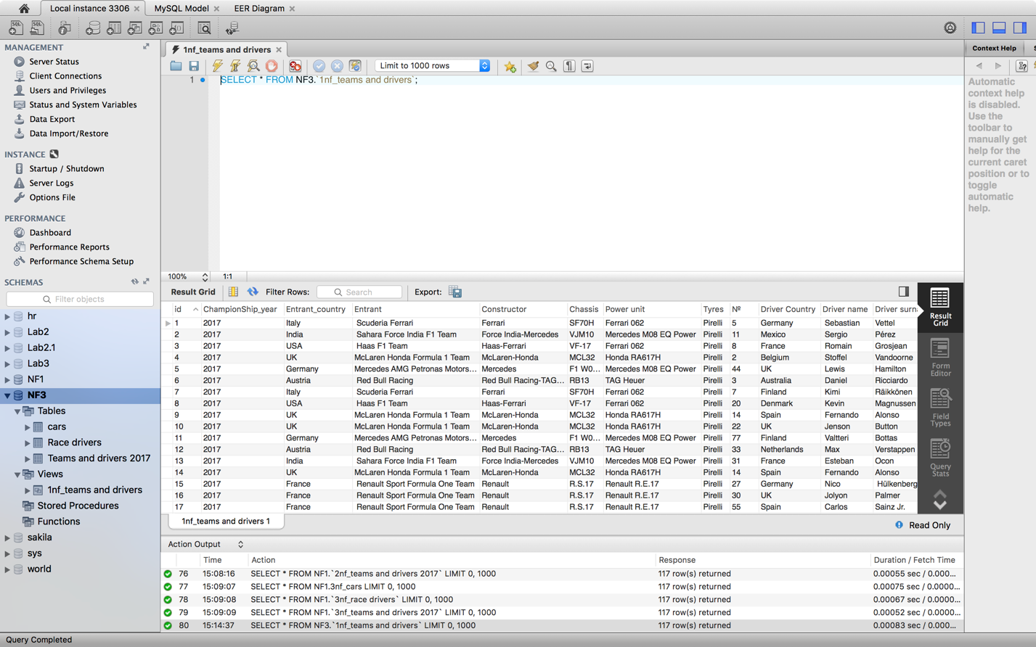

1. Написать запрос сравнивающий данные из представления для 1NF (см. Зад 2.1) и данные в таблице для 1NF и разницу вывести на экран.

SELECT

*

FROM

NF1.`Teams and drivers 2017`

left join NF3.`1nf_teams and drivers` on NF1.`Teams and drivers 2017`.id= NF3.`1nf_teams and drivers`.id;

